***Documentation for Bus Booking System***

**Admin View**

Steps 1: If the admin is login for first time, he /she need to do the SignUp

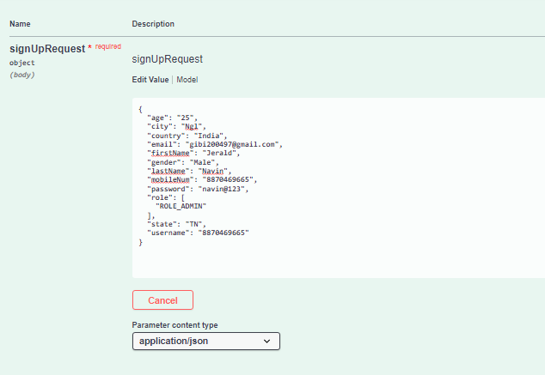

<http://localhost:8082/api/auth/signup>

Provide the required data and once we execute the above we will get the below response

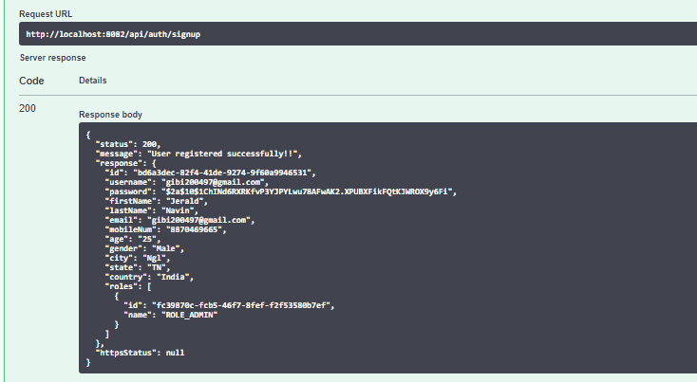

Step 2: Once Admin signup with his/her credentials , he can login with mail id and password

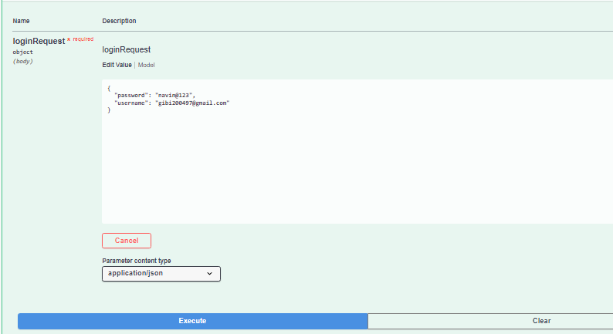

<http://localhost:8082/api/auth/signup>

Below is the response which Admin gets, when he logged in with his email and password

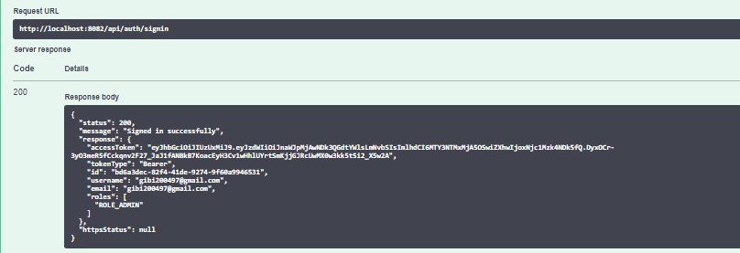

**Functionality of Admin**

Admin has the below privileges:

1. He can view all passengers by providing the bus id

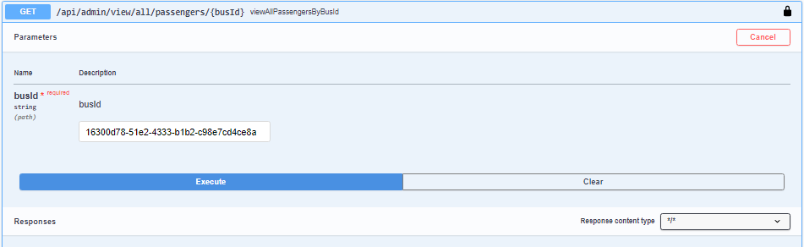

<http://localhost:8083/api/admin/view/all/passengers/047d69a5-ea77-4b6e-b6e5-6c56669b9227>

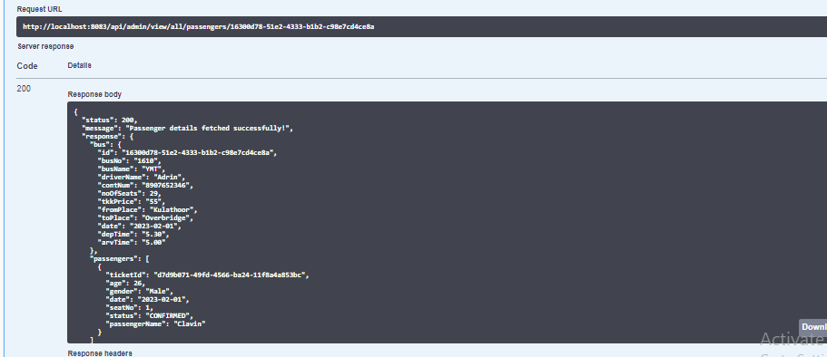

1. Save the bus details

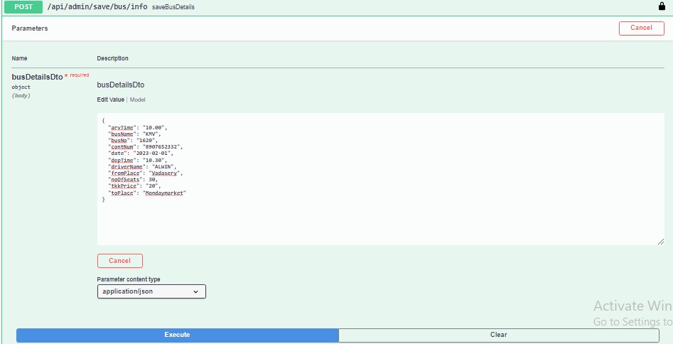

<http://localhost:8083/api/admin/save/bus/info>

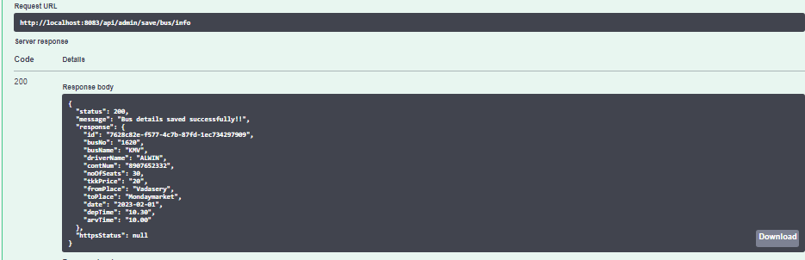

1. Update the bus details

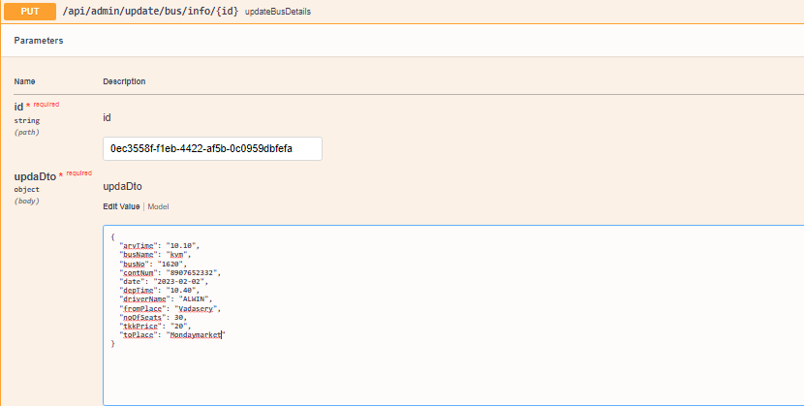

<http://localhost:8083/api/admin/update/bus/info/7628c82e-f577-4c7b-87fd-1ec734297909>

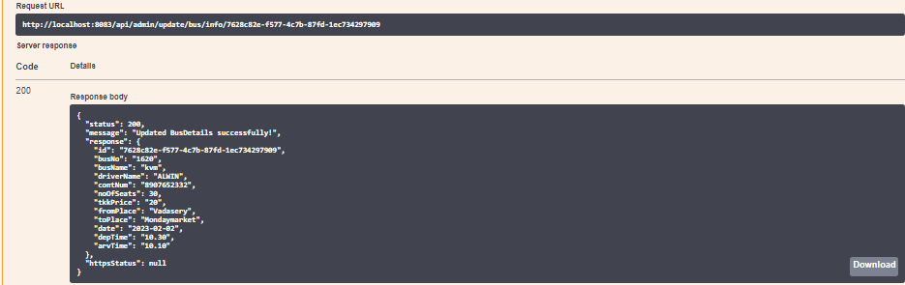

1. Cancel the bus

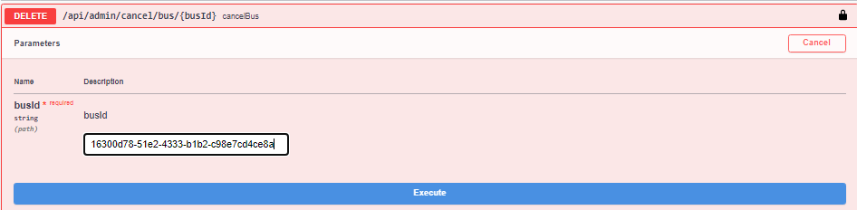

<http://localhost:8083/api/admin/cancel/bus/047d69a5-ea77-4b6e-b6e5-6c56669b9227>

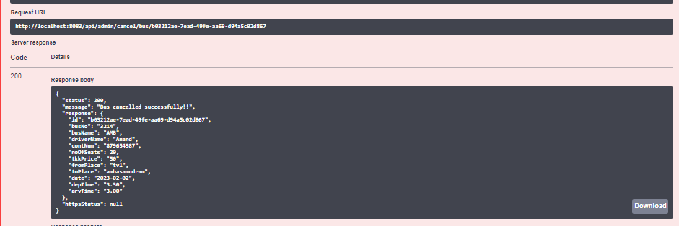

**USER VIEW**

Step 1: If the passenger is login for the first time, he/she need to do the signup

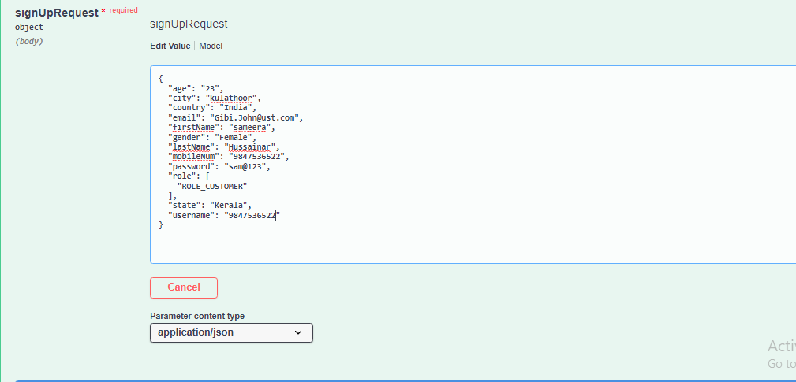

<http://localhost:8082/api/auth/signup>

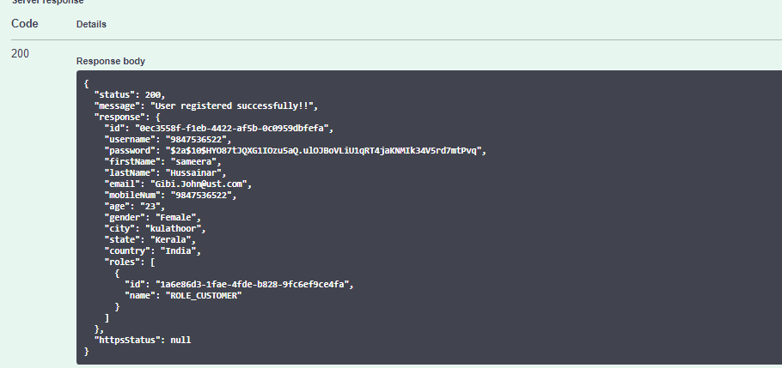

Step 2: Once user had registered, they can login with their mobile number and password

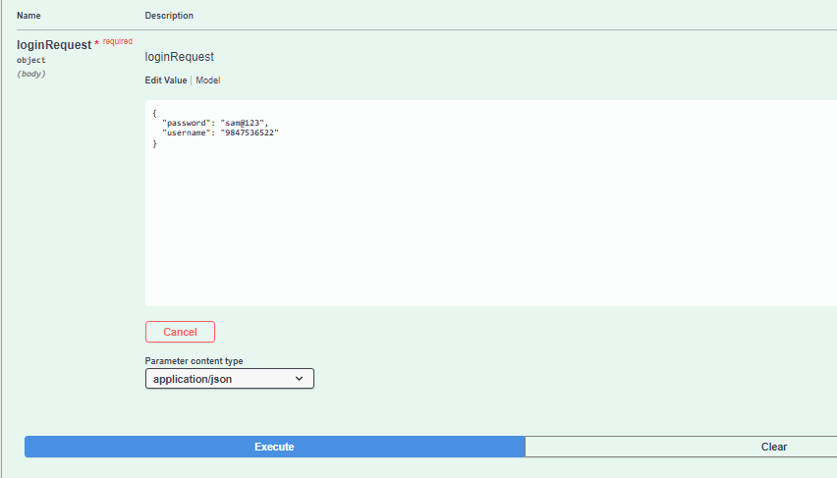

<http://localhost:8082/api/auth/signin>

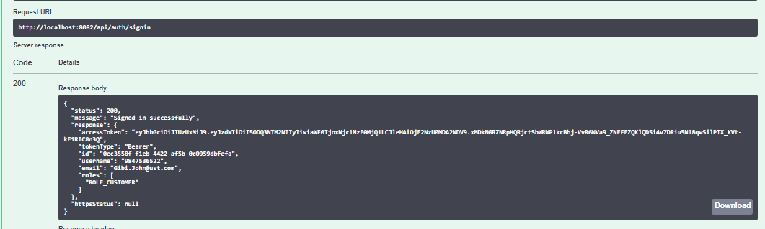

Step 3: Once they signed in, they can book their view the bus and book their bus.

**Functionality of customer view:**

1. User can login to the portal, and they can book their ticket. Once user is done with their ticket booking, they will receive an email notification.



<http://localhost:8084/api/user/book/ticket>

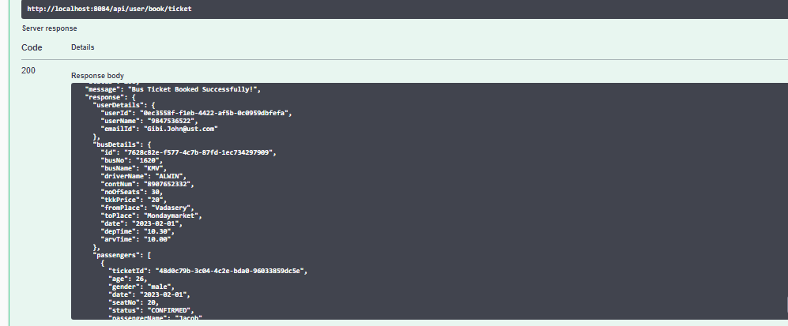

PDF is generated once passenger booked their ticket.

2. View all the bus

<http://localhost:8084/api/user/view/all/busDetails>

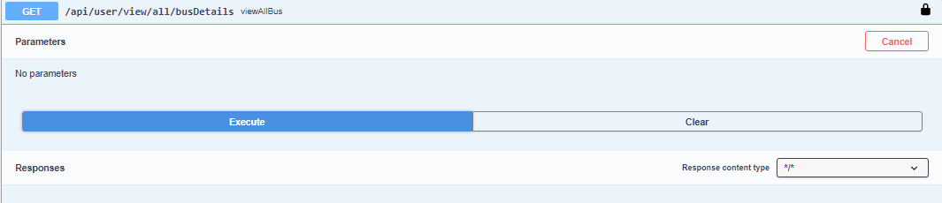

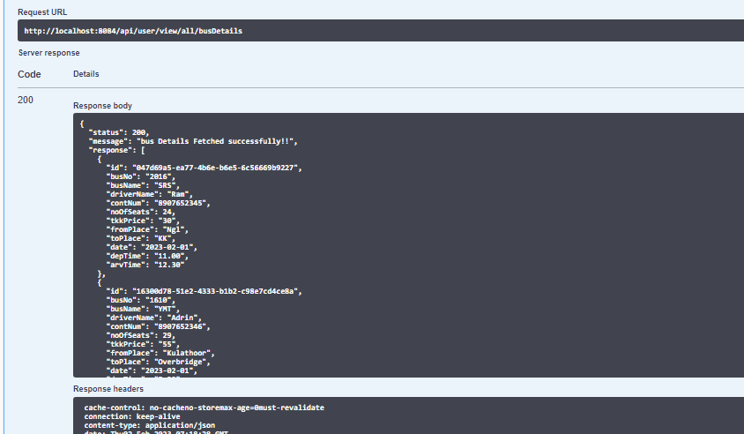

3. User can also search the places by filter option

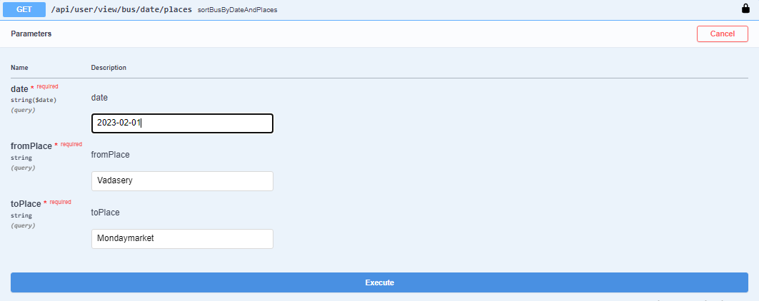

<http://localhost:8084/api/user/view/bus/date/places?date=2023-02-02&fromPlace=Vadasery&toPlace=Mondaymarket>

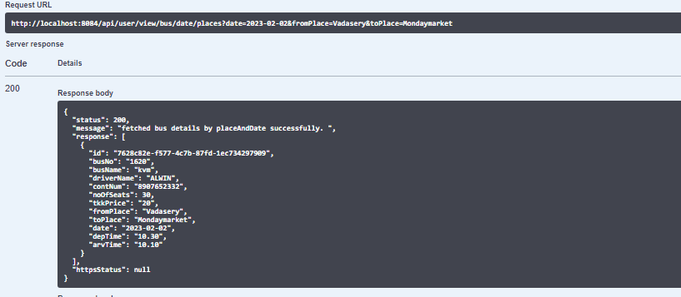

4. User can view their bus ticket using customer id

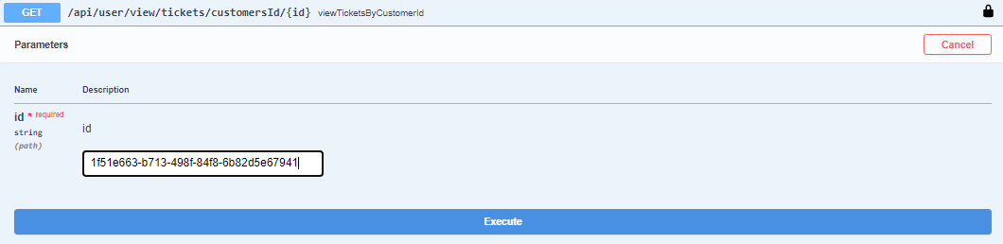

<http://localhost:8084/api/user/view/tickets/customersId/1f51e663-b713-498f-84f8-6b82d5e67941>

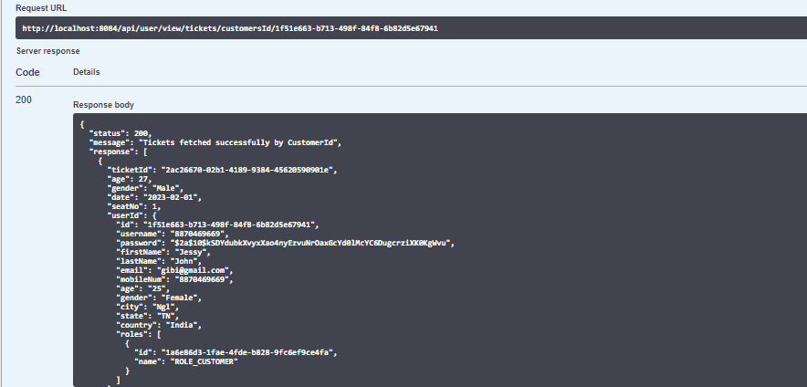

5. User can also view their ticket details using bus id

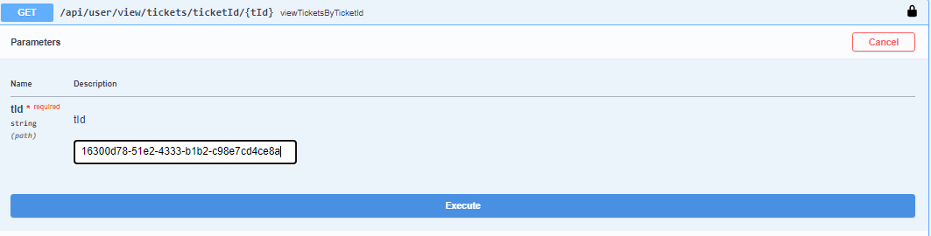

<http://localhost:8084/api/user/view/tickets/ticketId/d7d9b071-49fd-4566-ba24-11f8a4a853bc>

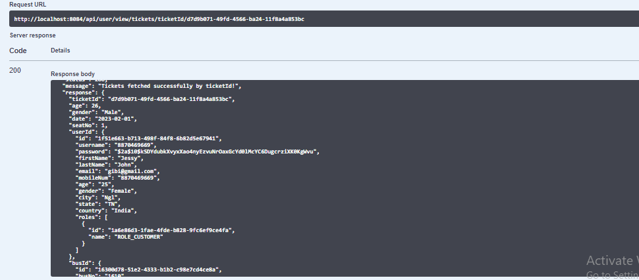

6. User can also cancel their bus ticket. Once they cancel the bus ticket, user will receive an email notification .

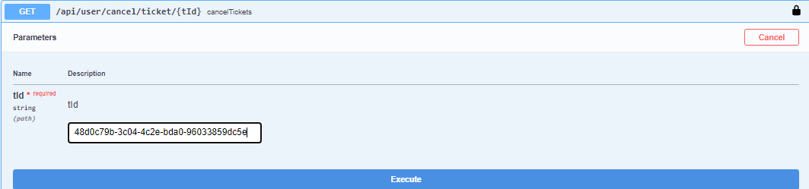

<http://localhost:8084/api/user/cancel/ticket/48d0c79b-3c04-4c2e-bda0-96033859dc5e>

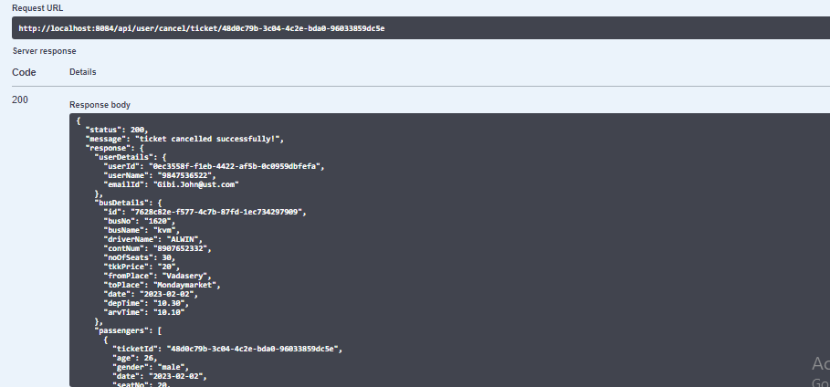

Once passenger cancelled the ticket, they will receive an email notification with cancelled status as attached in above pdf.